Campus Hire Training
Rule Book & Manual



INDEX
1. Rule book for trainees.
2. Important contact details
3. Set the Security Questions in the Syntelligence
4. Syntelligence password reset/unlock
5. Leaves- ‘as a trainee’
6. Attendance regularization/check
7. Assessment rules and regulations
8. Enable address bar and tool bar - IE browser:
9. Training shared folder location
10. Guidelines for accessing the ‘Thin Client’ machines

Rules for Trainees
Time Management and Discipline:
- You should be present in the class room before 9:00 a.m.
  - If you are late, it will be considered as LWP (Leave without Pay) for the day.
- Break Timings:
  - Morning Break Time – 11.00 AM to 11.15 AM
  - Lunch Time – 12.30 PM to 1.30 PM
  - Evening Break Time—4.00 PM to 4.15 PM
- Don’t roam outside the classroom except the break time.
- Use Restroom and wash area properly. Don’t spit chewing gum, tissues in urinal or toilet system.
- Don’t use any food items inside the classroom not even tea cups.
- Maintain the discipline inside campus everywhere like pantry, cafeteria, elevator etc.
- Switch off your mobile phones during the classroom session.
Applying leave in Syntelligence:
Syntelligence is the Syntel’s portal to be used especially for Attendance regularization and leave management. There are some rules to be followed while using it:
- You can login to Syntelligence using the systems assigned to you in the training room.
- You should login to Syntelligence within two days after the credentials are provided. Reset the security questions and password after the first login.
  - Login first time using default password
  - Reset the password
  - Click on profile icon(your employee id on the right side) and select Set Security Questions
- You should regularize your attendance in Syntelligence weekly once (Monday). If not, it will become LWP for the day automatically.
- You must not take leave during the training period. In case of emergency, you can apply for leave under the category LWP (Leave without Pay). If you take leaves for more than 3 days, you cannot continue in the same batch.
- If you need permission to go anywhere during working hours, you should get the permission from your trainer and Reporting manager (RM).

Other Rules :
- Log off the remote machines (don’t shutdown) every day before leaving for better
- Switch off the local machine and Projector every day before you leave.
- You should not create any files or folder under ‘training-Share’ folder.

Important Contact Details
Contact Person Name | Nortel No | Mobile No
Pratheeba Gunasekaran | 04441-8201
Fredrick Alphonseraj | 04441-8280 | 9962318660
Krithiga Ganapathy | 04441-5806 | 9176095375
Paranthaman Santhanam | 04441-8242 | 9884452825
Vijaykumar Reddypogu | 04441-8277
Janarthanan Selvaraj | 04441-2613
Medical room | 04441-8969
Selva (Transport) | 04441-3849
Kannan K (Access Card Issue) | 04441-8771
Shahina (HR) | 04441-8146
Ganesh (HR) Pay roll | 04441-8209
Mohan (HR) PF,ESF | 04441-8208

HR Contact Details
ID | First Name | Last Name | Designation |  | Nortel
5007733 | Venkatraman | Numbur Beemaraja | ERM | 04441-2445
5010790 | Sindhura | Kumaran | ERM | 04441-2568
5012949 | Nisha | Jayaraman | ERM | 04441-8731
5018093 | Sristi | Shikha | ERM | 04441-8788
5019607 | Aravindan | Ramamoorthy | ERM | 04441-5121
5021739 | Annie | Melinda | ERM | 04441-2480
5030315 | Gayathri | Prabhakar | ERM | 04441-3203
5032240 | Vigneshkumar | S | ERM | 04441-5185
29902 | Balamurugan | Dhanasekaran | HRSS | 04441-8211
5016200 | Sundarrajan | Ramamoorthy | HRSS | 04441-8329
5036706 | Vijayakumar | Gangatharan | HRSS | 04441-5606
5008193 | Saravanan | Sambasivam | PDAC | 04442-3336
5016067 | Driviam | Lawrence Joseph | PDAC | 04441-3170
5021554 | Lokesh | Manikanta Paila | PDAC | 04442-3366
5027823 | Saravanan | Manian | PDAC | 04442-3094
5028300 | Balaji | Arasu | PDAC | 04441-8526
5030949 | Anupama | Chandar | PDAC | 04442-3331
5031329 | Hema | Seethalakshmi | PDAC | 04442-3333
5032135 | Deepika | Srinivasan | PDAC | 04441-8861
31759 | Shireen | Rajan | PDAC
2000019 | Kannan | Govindan | Library | 04441-8279
5018131 | Divya | Venketraman | Training | 04441-2461

How to Set the Security Question in Syntelligence:
Step 1: Select the option which is marked 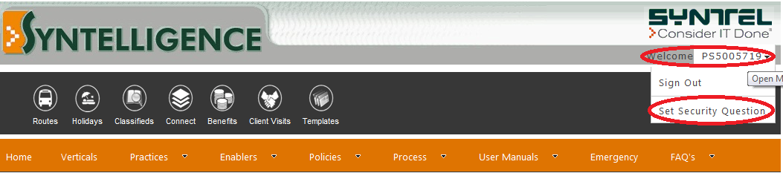
Step 1: Select the Questions & Answers and submit.
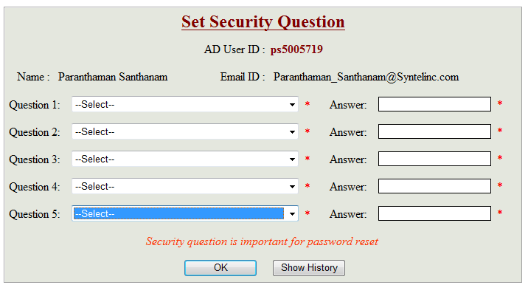
Login Password issues/Reset Password:
There are two options:
Option 1:
- Call 7222 from Nortel
- Enter Option 1 and Again 1.
- Get the solution from the Helpdesk executive

Option 2:
- Open the Self-help portal. Url address— https://selfhelp.syntelinc.com
- Provide the details asked in the web page to unlock your account or reset your password.
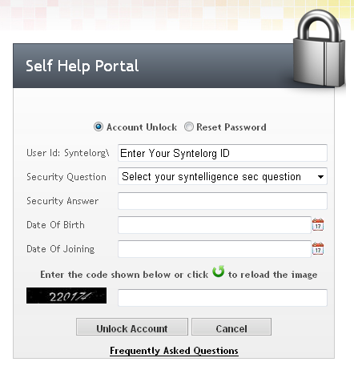
Other Options:
- 1. If you are working in Syntel LAN, to reset password on a PC press CTRL + ALT + Delete and select Change Password.
- 2. If you are not in LAN, you can use Webapp to reset your password. Login to Webapp1.syntelinc.com and go to - Options and Select see all option - Reset Password.
- 3. If you are travelling and have no access to Webapp or Syntel LAN, you can reach out to ServiceDesk and seek further assistance.
- 4. If you have BYOD (Smartphone, Tablet etc.) configured with syntelinc mail, kindly update new password in the device settings.
- If your mailbox is moved to O365, kindly use following URL to reset the password Https://webapp2.syntelinc.com/owa/auth/expiredpassword.aspx.

Leave Request:
- Trainees should not take leaves during the Training days.
- Postpone your passport enquiry/verification and your personal work after the training period.
- In case of emergency, you should get approval from your Trainer and RM and submit leave request form accordingly.
- After getting approval from RM, you should apply for leave in Syntelligence as well.

Follow the below steps for applying leave
Step1:
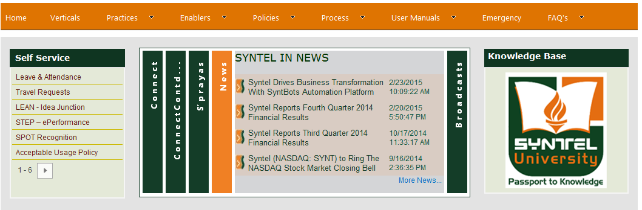
Step2:
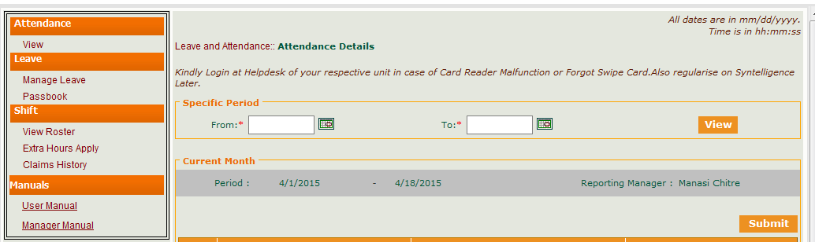

Step3: 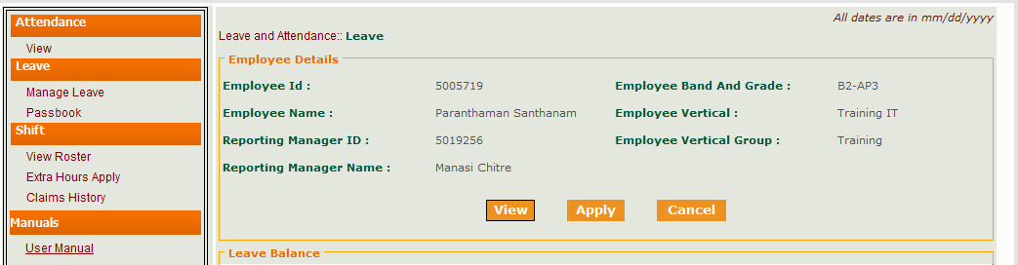

Step4:
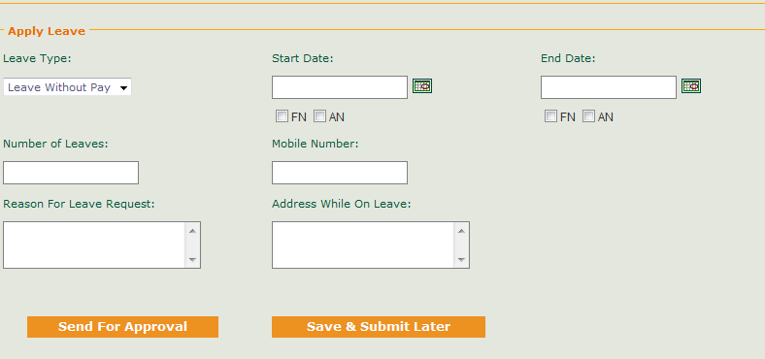

- NOTE: If anyone takes three consecutive days of leave, they cannot continue in the current batch. They have to wait for the next batch with same technology, and for the same session from wherever they had left the previous batch.
- If anyone takes leaves without intimation, they will be removed from the batch.
How to check and regularize your Attendance in Syntelligence:
- Attendance record of the current month can be viewed.
- You have to check your attendance and regularize it weekly

- In case of swipe issue – ‘less working hours’, ‘no swipe’; you have to select Personal Reasons from Justification column and enter the reason in it.
- Note that the Justification Column will be activated only after two days from current regularization date.

Follow the below steps to regularize your attendance:

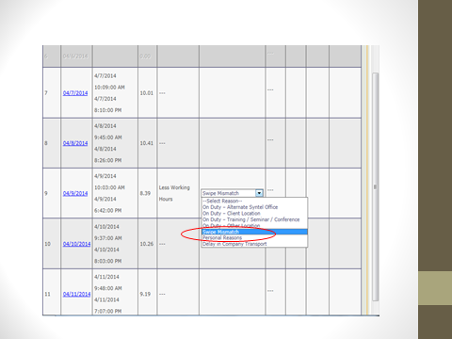

Assessment Rules and Regulation:
- Close the rest of the files from your machine.
- Make sure that you have entered the correct credentials in the login page.
- Don’t try to copy the answers from others.
- If there is any misconduct s or malpractices, invigilator will submit your assessment and send you out. It will be informed to the HR team to take necessary actions.
How to Enable Address Bar and Tool Bar of IE Browser:
- Go to run and enter regedit
- It will open Registry Editor window
- Select the below options
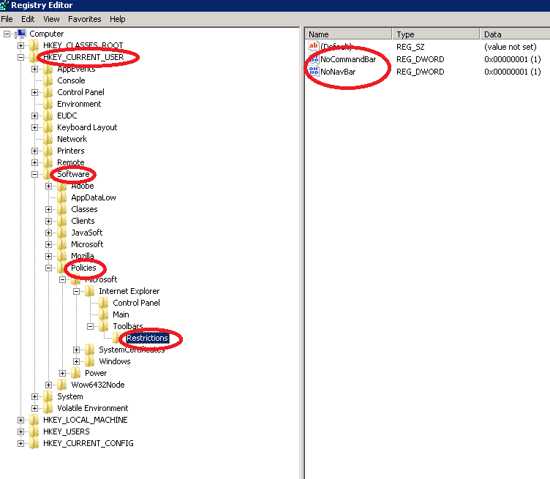
- Change the value from 1 to 0 in ‘value date’ text field.
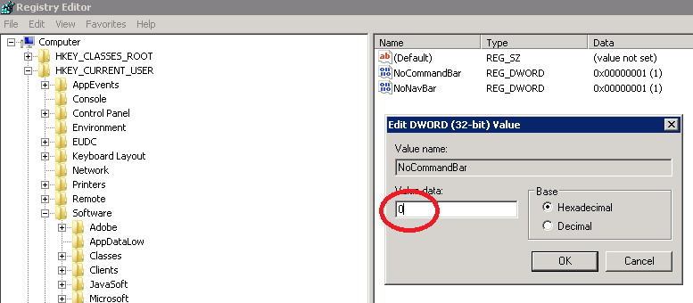

- You have to set zero for ‘NocommandBar’, ‘NoNavBar’.

Training Share Folder Location:
- All SYNTEL Training Reference Materials are available in the below shared folder location
\\172.26.100.9\Training-Share$\Training
- Your Result will be shared in the below folder
\\172.26.100.9\Training-Share$\Batch\Results

- Other Software files and information will be shared in the below folder
\\172.26.100.9\Training-Share$\Batch
Guideline for accessing the thin client machines
- You will be getting the unique id and password for accessing the remote machines. In case of shortage of machines, two users can use one machine.
- You can use any machines in the classroom and login with your user id and password provided to you. You should not access others user ids strictly. If two users are trying to connect with same user id, access will be blocked.
- Training materials are available in the shared folder. You have only read permission.
- There is a separate shared folder is created for each batch separately to save your documents. It will be announced by your Trainer. Then you should create a folder name start with employee id-your name. Save all the files only in your folders. If we find any files and folder in other location shared folder it will be deleted without indication.
- If you have any problems in the machines and software, you can log the details in the training portal.

How to set the Proxy for internet access:
- Open Mozilla Browser
- Click on Home Button
- Click on Setting Button from bottom
- Click Advanced Tab on Options window
- Select Network Tab
- Choose Manual Proxy Configuration option in the Connection settings window
- HTTP Proxy is 172.26.30.153
- Port is 8080
- Check the use this proxy server for all protocols
- Click OK button on Connection settings window
- Click OK button Options window

